Name: _______________________________________________________ Class #4: September 25th

1. If I put too many brackets in my code, is that a ***semantics***or a ***syntax*** error?
2. If my program is running, but everything is falling up instead of down, which type of error is that?
3. The debugging exercises are one of my favorite in-class puzzles. What did you think? How’d you do?

Feedback

1. Any questions or anything you want re-explained next class?
2. Do you feel caught up in class? What grade would you give yourself based on your understanding?
3. Anything else I can do to improve your learning experience?
4. 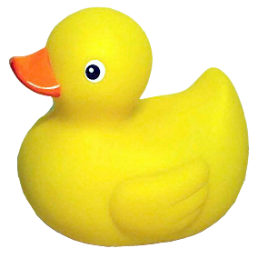Did I provide enough critique on your eclipse assignment?